Join IN SQL:
Combining row of 2 or more tables based on related columns between them. There are 4 different types of JOIN in SQL:
1- (INNER) JOIN: Returns rows having matching values in both tables.
2- LEFT JOIN: Returns all records of left table and the maching ones between them.
3- RIGHT JOIN: Returns all records of right table and the maching ones between them.
4- FULL JOIN: Returns all records when there is a match in left (table1) or right (table2) table records.

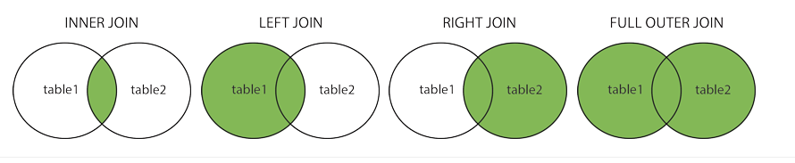
FIG 1: Different types of join in SQL

INNER JOIN:
SELECT column_name(s)
FROM table1
INNER JOIN table2
On table1.column_name =table2.column_name;

LEFT JOIN:
SELECT column_name(s)
FROM table1
LEFT JOIN table2
ON table1.column_name = table2.column_name;

RIGHT JOIN:
SELECT column_name(s)
FROM table1
RIGHT JOIN table2
ON table1.column_name = table2.column_name;

FULL OUTER JOIN:
SELECT column_name(s)
FROM table1
FULL OUTER JOIN table2
ON table1.column_name = table2.column_name;
WHERE condition;

